Alexander Cannell

2/7/2013

Professor Wu

A1: Riverside Financial

1.

2.

3.

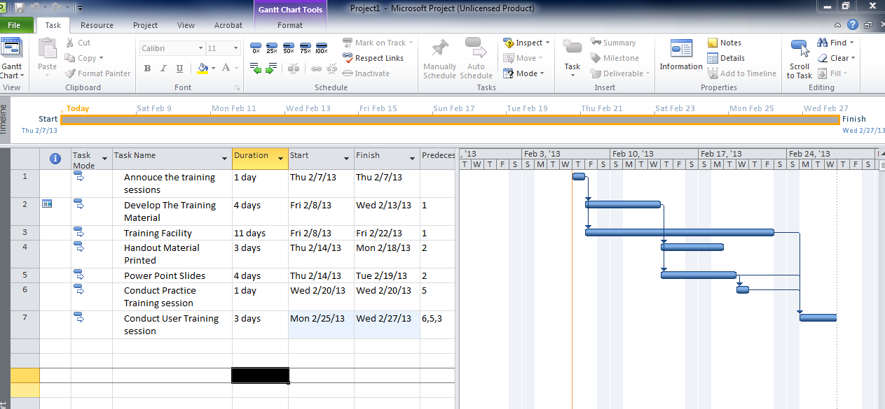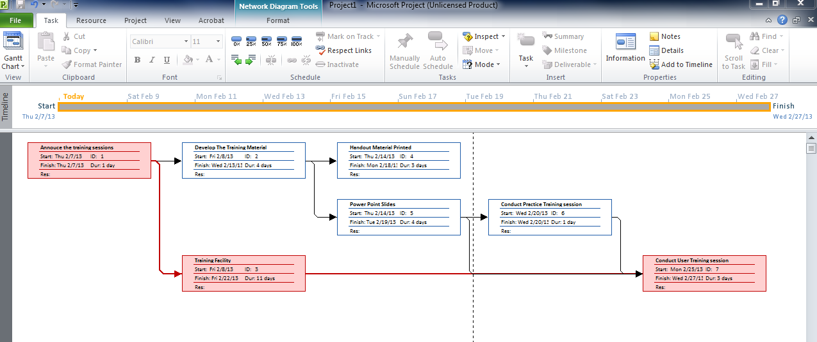

4. What is the critical path for this project? How do you Know?

What I found was the critical path was Annouce the training sessions => Training Facility => Conduct user training session. You can tell with the network Diagram.